### [Lucidchart Link](https://www.lucidchart.com/invitations/accept/e0345bbe-bc92-46ce-ac86-12054edad2d1)

### 

### 11/15/2018

Included Foreign Keys in their Tables and drew arrows showing what they reference in their foreign tables

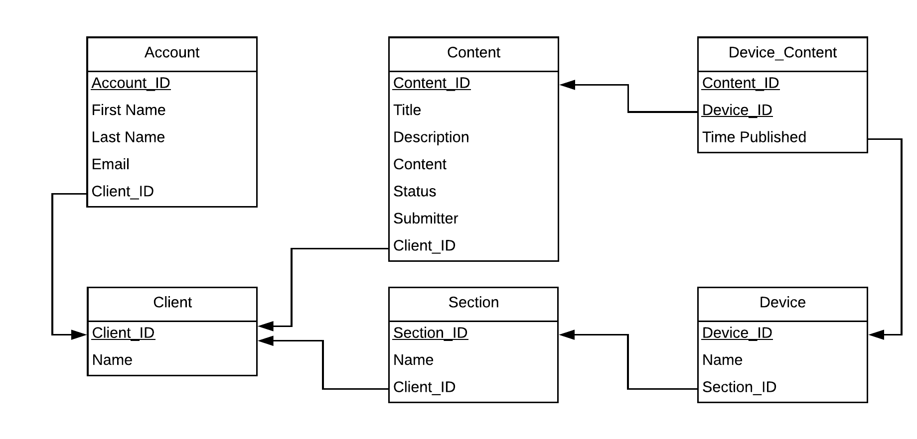

**Table Reduction**

|  |  |  |  |  |  |
| --- | --- | --- | --- | --- | --- |
| Account = (ID, First Name, Last Name, Email Address,Domain.ID, Role) | | | | | |
| **Account_ID** | **First Name** | **Last Name** | **Email Address** | **Domain_ID** | **Role** |
| 1 | Kal | Rabb | kxrvse@rit.edu | 1 | Client Account Admin |

|  |  |
| --- | --- |
| Client = (ID, Name) | |
| **Client_ID** | **Name** |
| 1 | RIT |

|  |  |  |
| --- | --- | --- |
| Device = (ID, Name, Client.ID) | | |
| **Device_ID** | **Name** | **Client_ID** |
| 1 | RIT | 1 |

|  |  |  |  |  |  |  |  |
| --- | --- | --- | --- | --- | --- | --- | --- |
| Content = (ID, Title, Description, Content, Status, Submited_Timestamp, Submitter_Email, Client.ID) | | | | | | | |
| **Content_ID** | **Title** | **Description** | **Content** | **Status** | **Submited_Timestamp** | **Submitter_Email** | **Client_ID** |
| 1 | Lost Student ID | I lost my student Id, please help me find it. Send me an email at mbd9441@rit.edu | Mbd9441@rit.edu | Pending Approval | 06:00:00 10/19/18 | Mbd9441@rit.edu | 1 |

|  |  |  |
| --- | --- | --- |
| Device_Content = (Device.ID, Content.ID, Published_Timestamp) | | |
| **Device_ID** | **Content_ID** | **Published_Timestamp** |
| 1 | 1 | 2018-10-15 12:00:00:00 |

|  |  |  |
| --- | --- | --- |
| Device_Content=(Content_ID, Device_ID, TIme Published) | | |
| **Content_ID** | **Device_ID** | **Time Published** |
| 1 | 1 | 12/12/18 11:11:11 |

**10/12/18**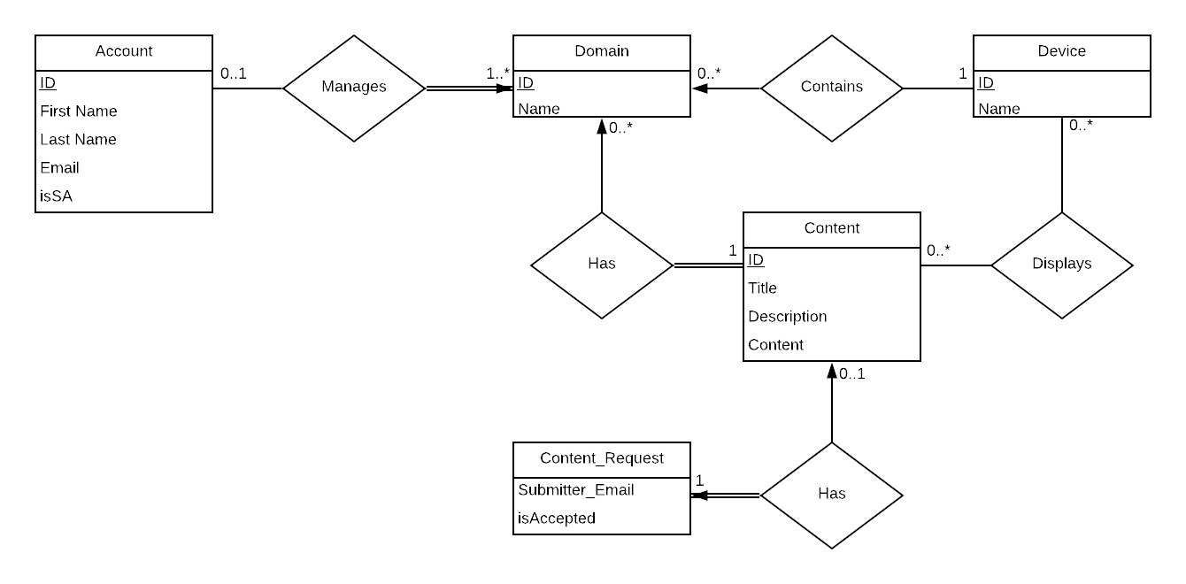

1. **Account** can be linked to 0 domains if SA, or 1 if not. **Domain** can have 1 or many accounts
2. **Domain** has 0 or many devices, **device** has to have 1 and only 1 domain
3. **Domain** has 0 or many content, **content** has to have 1 and only 1 domain
4. **Device** displays 0 or many content, **content** can be displayed on 0 or many devices
5. **Content** has 0 or 1 content request, **content** request has 1 and only 1 content

# Table Reduction

|  |  |  |  |  |  |
| --- | --- | --- | --- | --- | --- |
| Account = (ID, First Name, Last Name, Email Address, isSA,Domain.ID) | | | | | |
| **ID** | **First Name** | **Last Name** | **Email Address** | **isSA** | **Domain.ID** |
| 1 | Kal | Rabb | kxrvse@rit.edu | FALSE | 1 |

|  |  |
| --- | --- |
| Domain = (ID, Name) | |
| **ID** | **Name** |
| 1 | RIT |

|  |  |  |
| --- | --- | --- |
| Device = (ID, Name, Domain.ID) | | |
| **ID** | **Name** | **Domain.ID** |
| 1 | RIT | 1 |

|  |  |  |  |
| --- | --- | --- | --- |
| Content = (ID, Title, Description, Content) | | | |
| **ID** | **Title** | **Description** | **Content** |
| 1 | Hallway | Lost Student ID | I lost my student Id, please help me find it. Send me an email at mbd9441@rit.edu |

|  |  |  |
| --- | --- | --- |
| Content = (Submitter_Email, IsAccepted, Content.ID) | | |
| **Submitter_Email** | **IsAccepted** | **Content.ID** |
| mbd9441@rit.edu | TRUE | 1 |

|  |  |
| --- | --- |
| Content_to_Domain = (Domain.ID, Content.ID) | |
| **Domain.ID** | **Content.ID** |
| 1 | 1 |

|  |  |
| --- | --- |
| Content_to_Device = (Device.ID, Content.ID) | |
| **Device.ID** | **Content.ID** |
| 1 | 1 |